



**Placement Empowerment Program**

***Cloud Computing and DevOps Centre***

***Set up a cloud-based monitoring service:Enable basic cloud monitoring .view metrics like cpu usage and disk I/O for your cloud vm.***

Name:M Anumitha Department:AML



**INTRODUCTION:**

**OVERVIEW:**

Cloud-based monitoring is essential for tracking the performance and health of virtual machines (VMs) in a cloud environment. By enabling basic monitoring, users can view key metrics such as CPU usage, disk I/O, memory consumption, and network activity, ensuring optimal resource utilization and system reliability. This helps in detecting potential issues early, optimizing costs, and improving overall performance. Cloud providers like AWS, Azure, and Google Cloud offer built-in monitoring tools that provide real-time insights, helping businesses maintain efficiency, security, and compliance in their cloud infrastructure.

Top of FormBottom of Form

**OBJECTIVE:**

The objective of setting up a cloud-based monitoring service is to provide real-time visibility into the performance and health of virtual machines (VMs) by tracking key metrics such as CPU usage, disk I/O, memory consumption, and network activity. Effective monitoring ensures optimal resource utilization, helps identify performance bottlenecks, and enables proactive issue resolution to prevent downtime. Additionally, it enhances security by detecting anomalies and supports cost management by preventing resource wastage. By leveraging cloud providers’ built-in monitoring tools, such as AWS CloudWatch, Azure Monitor, or Google Cloud Operations Suite, users can analyze system performance, set up alerts, and automate responses to maintain high availability, security, and operational efficiency.

**Top of Form**

**Importance of Setting Up a Cloud-Based Monitoring Service**

* **Real-Time Performance Tracking** – Monitors key metrics like CPU usage, disk I/O, and network activity.
* **Early Issue Detection** – Identifies potential problems before they cause downtime.
* **Optimized Resource Utilization** – Helps in balancing workloads and preventing overuse or underuse of resources.
* **Cost Efficiency** – Reduces unnecessary cloud expenses by preventing resource wastage.
* **Enhanced Security** – Detects anomalies in system behavior to prevent potential threats.
* **Automated Alerts & Responses** – Triggers notifications and automated actions for quick issue resolution.
* **Improved Decision-Making** – Provides insights into system performance for better cloud infrastructure management.

**STEP BY STEP OVERVIEW:**

**STEP 1:**

Go to azure portal and create a virtual machine with a specified region,location,and server.

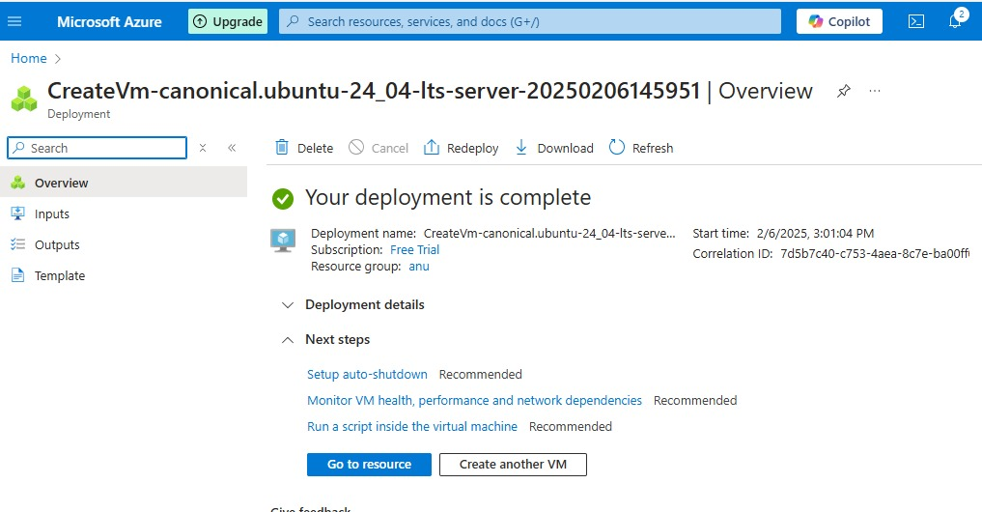

**STEP 2:**

Go to the search bar in the left-side menu ,under choose insights to enable the monitoring configuration:

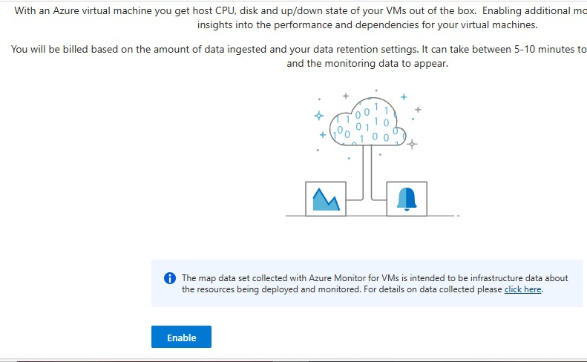

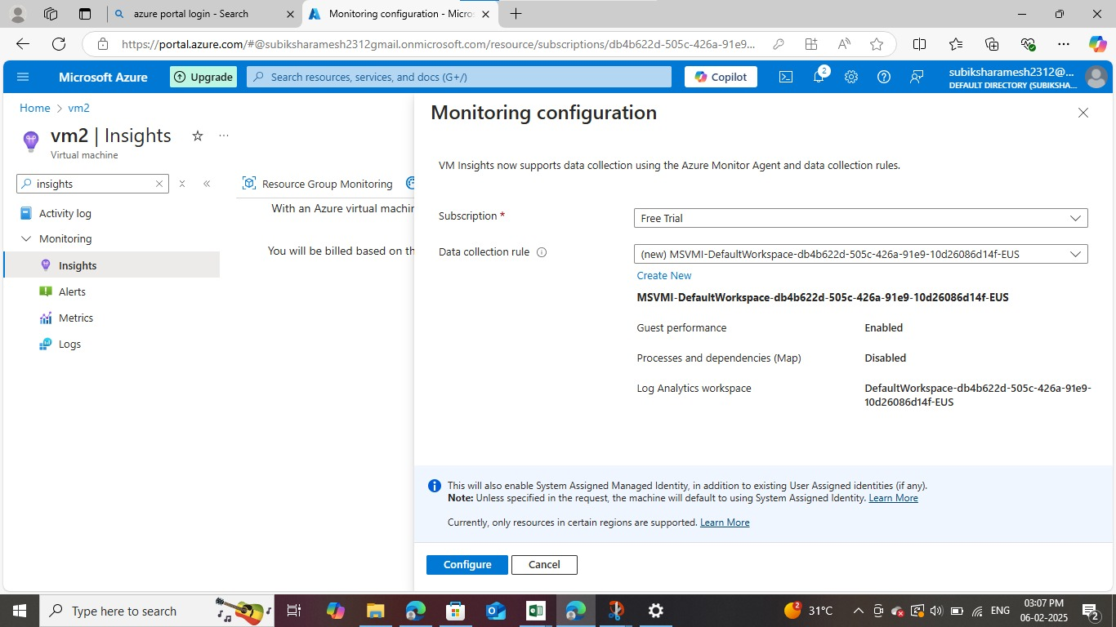

**STEP 3:**

Go to metrics to view the cpu performance in the graph format to the virtual machine:

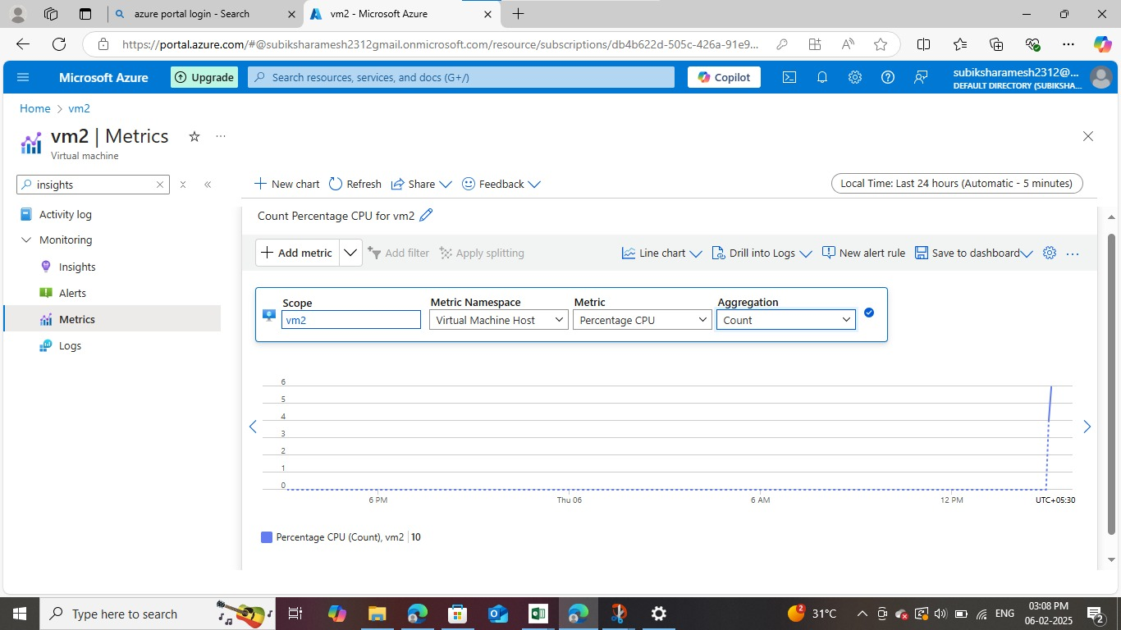

**STEP 4:**

Move to alerts and create a alert rule to give alerts to specified IT team to update the cpu exceeds the specified limit.

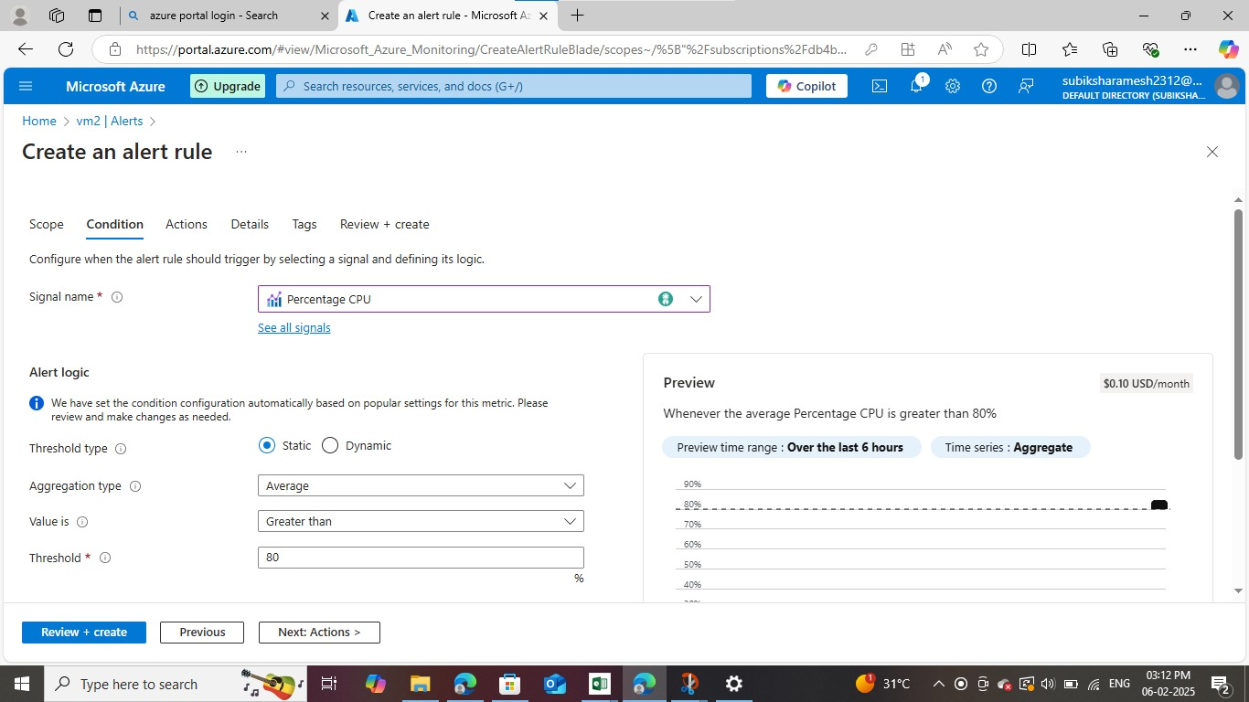

**STEP 5:**

Create action groups to specify notifications informations like email/sms/message to specified team

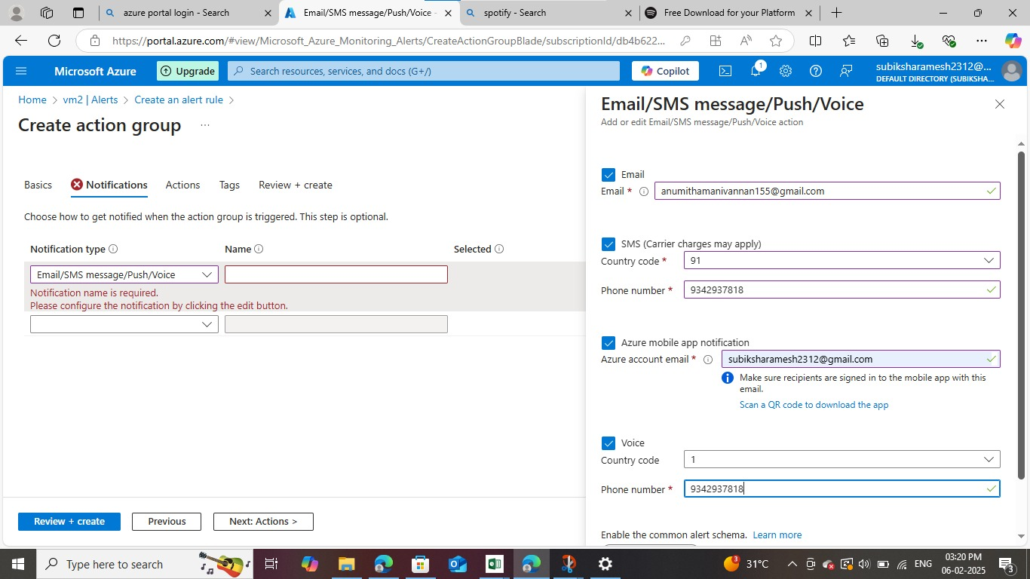

**STEP 6:**

You can view the created action groups is enabled,

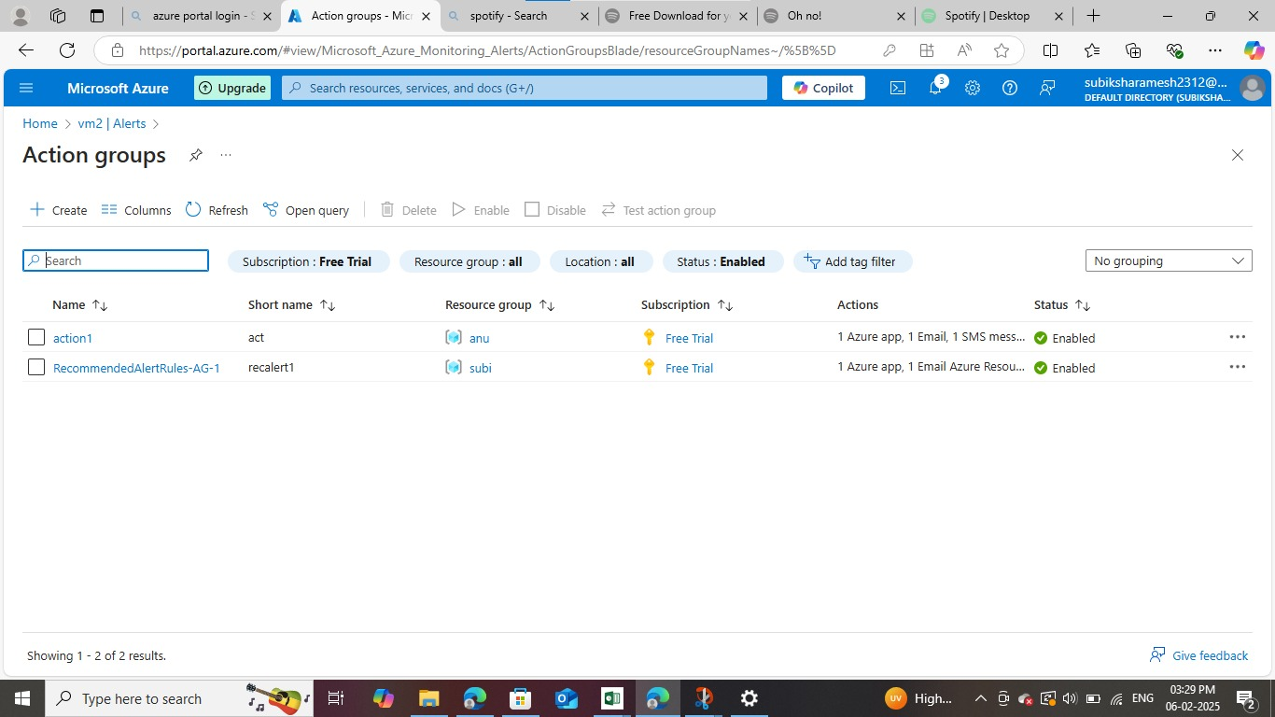

**STEP 7:**

There is no alerts are generated nowitself for the vm which i have created under the resource group:

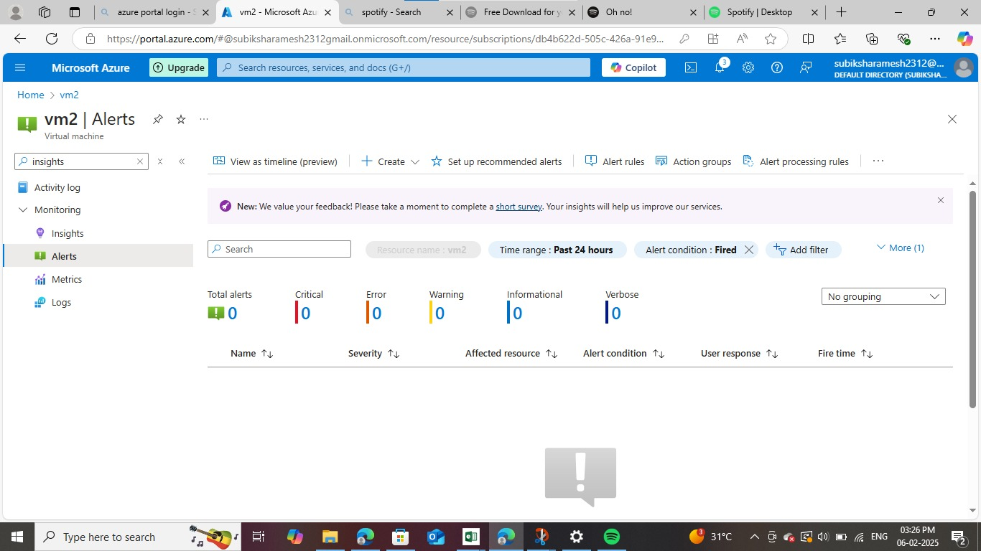

**EXPECTED OUTCOME:**

* Improved System Performance – Ensures optimal VM performance by monitoring resource utilization.
* Early Problem Detection – Identifies issues before they escalate, reducing downtime.
* Optimized Resource Allocation – Balances workloads efficiently, preventing overuse or underuse of resources.
* Cost Savings – Helps manage cloud expenses by minimizing unnecessary resource consumption.
* Enhanced Security – Detects unusual activity, reducing the risk of cyber threats and system breaches.
* Automated Issue Resolution – Enables automatic alerts and actions to address performance issues in real-time.
* Better Decision-Making – Provides valuable insights and analytics for efficient cloud infrastructure management.

4o